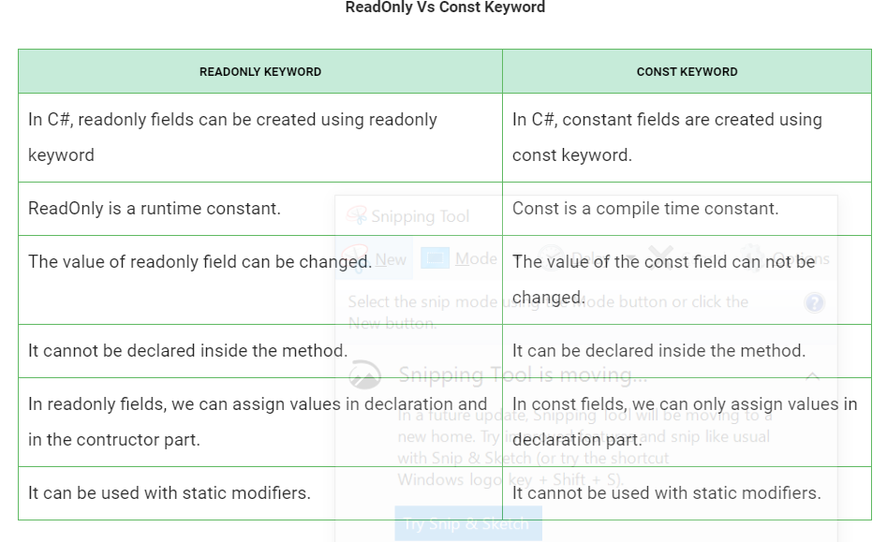

Linq Query

Enable us to **query** any type of data **sources**(like sql server,XML Document)

Linq query provide the **intelisense** and compile time error checking

Linq query operators-

Select

From

Where

Order by

Join

Group by

There are two way to write linq queries using these

1. Lambda expression
2. Sql like query expression

NOTE-



Git Stash

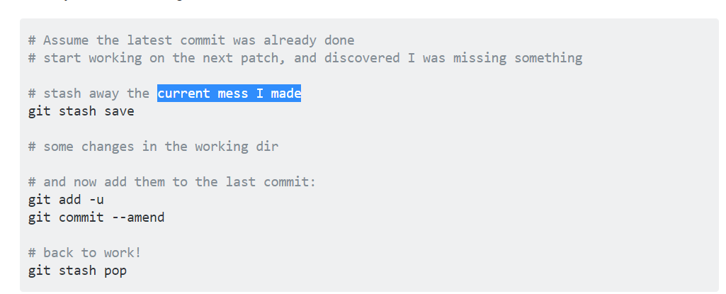

Lambda Expression



Emp **goes** to empl.id equal 102

Lambda expressions are **anonymous** functions that contain expressions or sequence of **operators**.

All lambda expressions use the **lambda operator** =>, that can be read as **“goes to**” or “becomes”.

The **left side** of the lambda operator specifies the **input parameters** and the right side holds **an expression** or a code block that works with the **entry parameters**.

Usually lambda expressions are used as predicates or **instead of delegates (**a type that references a method).

1. List<Dog> dogs = **new** List<Dog>() {
2. **new** Dog { Name = "Rex", Age = 4 },
3. **new** Dog { Name = "Sean", Age = 0 },
4. **new** Dog { Name = "Stacy", Age = 3 }
5. };

* [public](https://docs.microsoft.com/en-us/dotnet/csharp/language-reference/keywords/public): The type or member can be accessed by any other code in the same assembly or another assembly that references it.
* [private](https://docs.microsoft.com/en-us/dotnet/csharp/language-reference/keywords/private): The type or member can be accessed only by code in the same class or struct.
* [protected](https://docs.microsoft.com/en-us/dotnet/csharp/language-reference/keywords/protected): The type or member can be accessed only by code in the same class, or in a class that is derived from that class.
* [internal](https://docs.microsoft.com/en-us/dotnet/csharp/language-reference/keywords/internal): The type or member can be accessed by any code in the same assembly, but not from another assembly.
* [protected internal](https://docs.microsoft.com/en-us/dotnet/csharp/language-reference/keywords/protected-internal): The type or member can be accessed by any code in the assembly in which it's declared, or from within a derived class in another assembly.
* [private protected](https://docs.microsoft.com/en-us/dotnet/csharp/language-reference/keywords/private-protected): The type or member can be accessed only within its declaring assembly, by code in the same class or in a type that is derived from that class.

### **What is the difference between a Temporary Table and a Table Variable**

****What is the difference between a Temporary Table and a Table Variable?****  
Or  
****When do you use Table Variable over a Temporary Table and vice versa?****  
  
  
****1.**** **Table variable** is created in the **memory** where as a

temporary table is created in the **TempDB**. But, if there is a memory pressure, the pages belonging to a table variable may be pushed out to tempdb.  
  
  
****2.**** Table variables cannot be involved in transactions, logging or locking.

This makes table variable **faster** than a temporary table.  
  
  
****3.**** You can pass table variable as **parameter** to **functions** and stored procedures, where as you cannot do the same with **temporary table.**  
  
****4.**** A temporary table can have indexes, whereas a table variable can only have a primary index. If speed is an issue Table variables can be faster, but if there are a lot of records, or there is a need to search the temporary table based on a clustered index, then a Temporary Table would be better. If you have less than 100 rows generally use a table variable. Otherwise use a temporary table. This is because SQL Server won't create statistics on table variables.

****What is Cascading referential integrity constraint?****  
****Cascading referential integrity constraints**** allow you to define the actions Microsoft SQL Server should take when a **user attempts** to **delete or update a key** to which an existing foreign keys point.  
 ****You can instruct SQL Server to do the following:****  
  
****1. No Action:**** This is the default behaviour. No Action specifies that if an attempt is made to delete or update a row with a key referenced by foreign keys in existing rows in other tables, an error is raised and the DELETE or UPDATE is rolled back.  
  
****2. Cascade:**** Specifies that if an attempt is made to delete or update a row with a key referenced by foreign keys in existing rows in other tables, all rows containing those foreign keys are also deleted or updated.  
  
****3. Set NULL:**** Specifies that if an attempt is made to delete or update a row with a key referenced by foreign keys in existing rows in other tables, all rows containing those foreign keys are set to NULL.   
  
****4. Set Default:**** Specifies that if an attempt is made to delete or update a row with a key referenced by foreign keys in existing rows in other tables, all rows containing those foreign keys are set to default values.  
  
****DIfference between primary key and unique key in SQL Server?****  
1. A table can have **only one primary key.** On the other hand a table can hav**e more than one unique key.**  
2. Primary key column does not accept **any null values**, where as a unique key column accept **one null** value.

You can have a where clause in **Delete** statement **where** as **Truncate statement** cannot have a **where** clause.

Truncate will delete all the **rows** in a Table, but the structure of the table remains.

Drop would delete **all the rows** including the structure of the Table.

## Difference between Abstraction and Encapsulation

The following are the differences between abstraction and [encapsulation](https://www.tutlane.com/tutorial/csharp/csharp-encapsulation" \o "C# Encapsulation with Examples" \t "https://www.tutlane.com/tutorial/csharp/_blank) in c# programming language.

| **Abstraction** | **Encapsulation** |
| --- | --- |
| It is used to hide unwanted data and shows only the required properties and methods. | It is used to bind data members and member functions into a single unit to prevent outsiders to access it directly. |

Encapsulation

•Technically in encapsulation, the variables or data of a class are hidden from any other class and can be accessed only through any member function of own class in which they are declared.

•As in encapsulation, the data in a class is hidden from other classes, so it is also known as data-hiding.

•Encapsulation can be achieved by: Declaring all the variables in the class as private and using C# Properties in the class to set and get the values of variables.

**HTML DOM**

## The HTML DOM (Document Object Model)

When a web page is loaded, the browser creates a ****D****ocument ****O****bject ****M****odel of the page.

The ****HTML DOM**** model is constructed as a tree of ****Objects****:

### The HTML DOM Tree of Objects



<html>  
<body>  
  
<p id="demo"></p>  
  
<script>  
document.getElementById("demo").innerHTML = "Hello World!";  
</script>  
  
</body>  
</html>

In the example above, getElementById is a ****method****, while innerHTML is a ****property****.

## The getElementById Method

The most common way to access an HTML element is to use the id of the element.

In the example above the getElementById method used id="demo" to find the element.

## The innerHTML Property

The easiest way to get the content of an element is by using the innerHTML property.

The innerHTML property is useful for getting or replacing the content of HTML elements.

The innerHTML property can be used to get or change any HTML element, including <html> and <body>.

## Finding HTML Elements

|  |  |
| --- | --- |
| **Method** | **Description** |
| document.getElementById(id) | Find an element by element id |
| document.getElementsByTagName(name) | Find elements by tag name |
| document.getElementsByClassName(name) | Find elements by class name |

## Changing HTML Elements

|  |  |
| --- | --- |
| **Property** | **Description** |
| element.innerHTML =  new html content | Change the inner HTML of an element |
| element.attribute = new value | Change the attribute value of an HTML element |
| element.style.property = new style | Change the style of an HTML element |
| **Method** | **Description** |
| element.setAttribute(attribute, value) | Change the attribute value of an HTML element |

|  |
| --- |
| **[next →](https://www.javatpoint.com/c-sharp-static)[← prev](https://www.javatpoint.com/c-sharp-destructor)** C# this In c# programming, this is a keyword that refers to the current instance of the class. There can be 3 main usage of this keyword in C#.   * It can be used **to refer current class instance variable**. It is used if field names (instance variables) and parameter names are same, that is why both can be distinguish easily. * It can be used **to pass current object as a parameter to another method**. * It can be used **to declare indexers**. |

What are Constraints in SQL?

Constraints are used to specify the rules concerning data in the table. It can be applied for single or multiple fields in an SQL table during creation of table or after creationg using the ALTER TABLE command. The constraints are:

NOT NULL - Restricts NULL value from being inserted into a column.

CHECK - Verifies that all values in a field satisfy a condition.

DEFAULT - Automatically assigns a default value if no value has been specified for the field.

UNIQUE - Ensures unique values to be inserted into the field.

INDEX - Indexes a field providing faster retrieval of records.

PRIMARY KEY - Uniquely identifies each record in a table.

FOREIGN KEY - Ensures referential integrity for a record in another table.

## ****Q12. What do you mean by data integrity?****

Data Integrity defines the **accuracy** as well as the **consistency** of the data stored in a database. It also defines integrity constraints to enforce business rules on the data when it is entered into an application or a database.

## ****Q24. What do you mean by “Trigger” in SQL?****

Trigger in SQL is are a special type of stored procedures that are defined to execute automatically in place or after data modifications. It allows you to execute a batch of code when an insert, update or any other query is executed against a specific table.

## ****Q25. What are the different operators available in SQL?****

There are three operators available in SQL, namely:

1. Arithmetic Operators
2. Logical Operators
3. Comparison Operators

## ****Are NULL values same as that of zero or a blank space?****

A NULL value is **not at all** same as that of zero or a blank space. NULL value represents a value which is **unavailable**, **unknown, assigned or not applicable** whereas a zero is a **number** and **blank space is a character.**

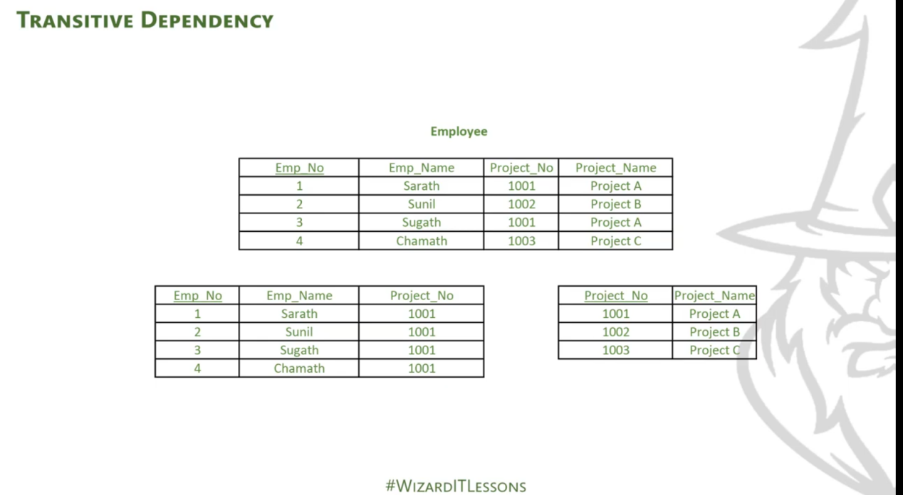

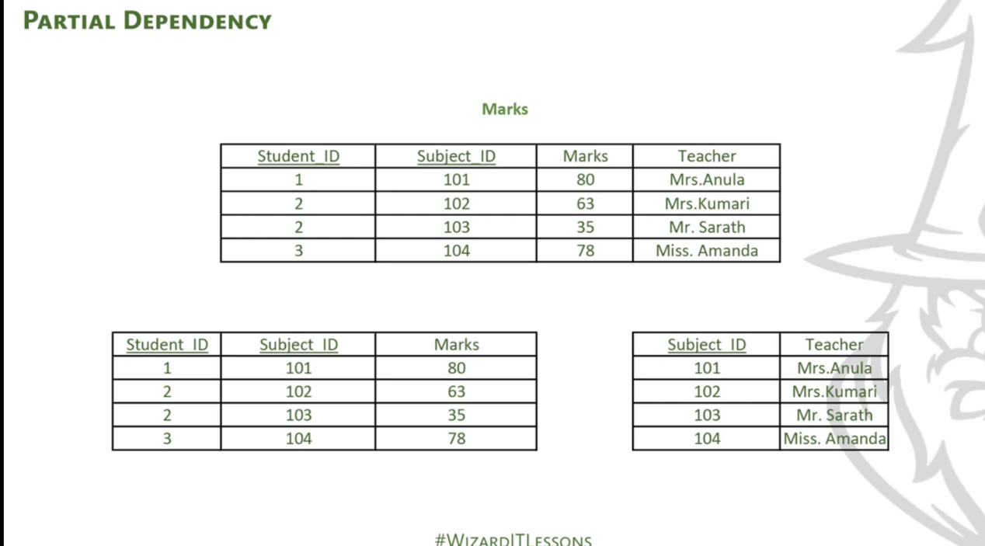

## **List some advantages and disadvantages of Stored Procedure?**

### ****Advantages****:

A Stored Procedure can be used as a modular programming which means **create once, store and call** for several **times whenever it is required.**

This supports faster execution. It also reduces **network traffic and provides better security** to the data.

## **List all the types of user-defined functions?**

There are three types of user-defined functions, namely:

* Scalar Functions
* Inline Table-valued functions
* Multi-statement valued functions

What are Aggregate and Scalar functions?

An aggregate function performs operations on a collection of values to return a single scalar value. Aggregate functions are often used with the GROUP BY and HAVING clauses of the SELECT statement. Following are the widely used SQL aggregate functions:

AVG() - Calculates the mean of a collection of values.

COUNT() - Counts the total number of records in a specific table or view.

MIN() - Calculates the minimum of a collection of values.

MAX() - Calculates the maximum of a collection of values.

SUM() - Calculates the sum of a collection of values.

FIRST() - Fetches the first element in a collection of values.

LAST() - Fetches the last element in a collection of values.

Note: All aggregate functions described above ignore NULL values except for the COUNT function.

A scalar function returns a single value based on the input value. Following are the widely used SQL scalar functions:

LEN() - Calculates the total length of the given field (column).

UCASE() - Converts a collection of string values to uppercase characters.

LCASE() - Converts a collection of string values to lowercase characters.

MID() - Extracts substrings from a collection of string values in a table.

CONCAT() - Concatenates two or more strings.

RAND() - Generates a random collection of numbers of given length.

ROUND() - Calculates the round off integer value for a numeric field (or decimal point values).

NOW() - Returns the current data & time.

FORMAT() - Sets the format to display a collection of values.

Constructor

If we create parameterize constructor, and then if we want to create object then definitively we want create paramterless constructor.

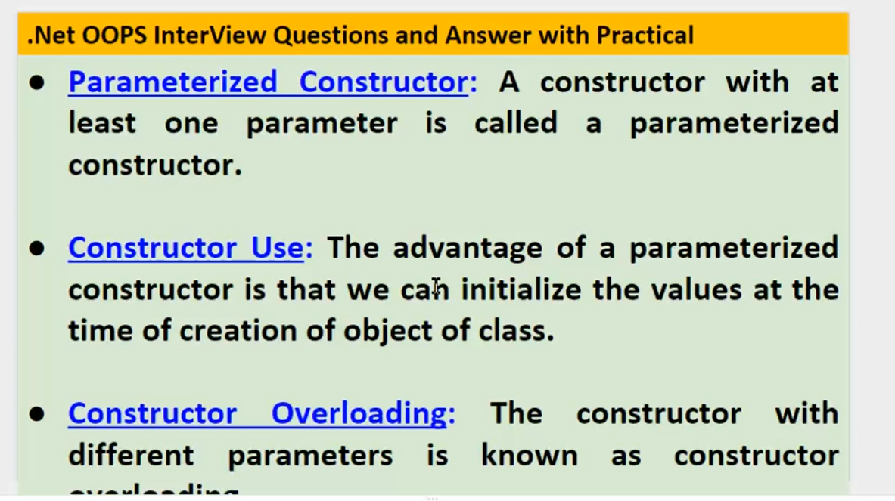

## Predefined Data Types in C#

C# includes some predefined value types and reference types. The following table lists predefined data types:

int i = default(int); // 0

float f = default(float);// 0

decimal d = default(decimal);// 0

bool b = default(bool);// false

char c = default(char);// '\0'

// C# 7.1 onwards

int i = default; // 0

float f = default;// 0

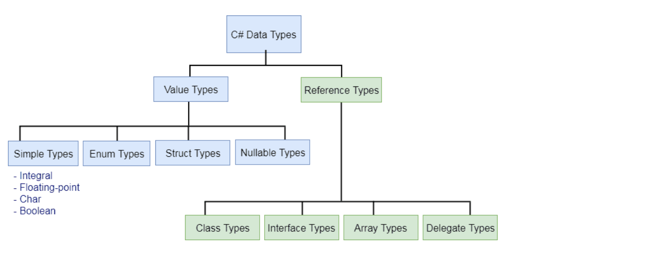

**Extension Method**

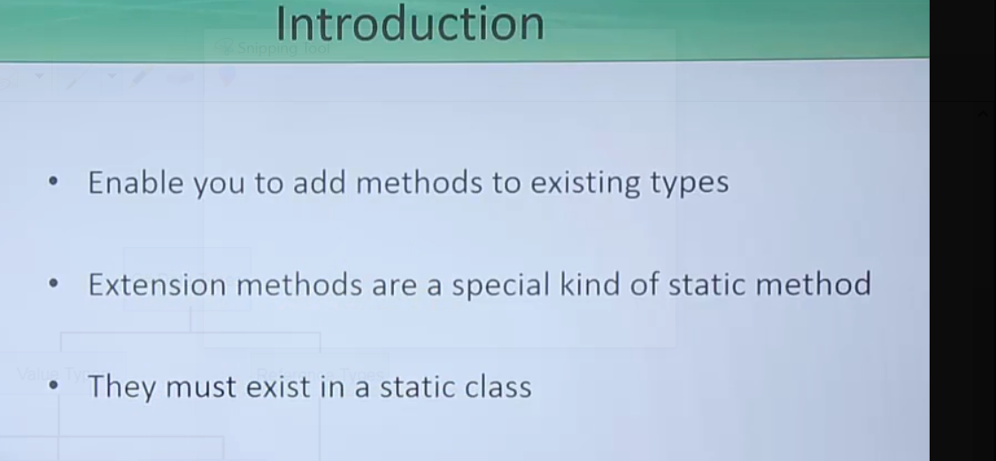

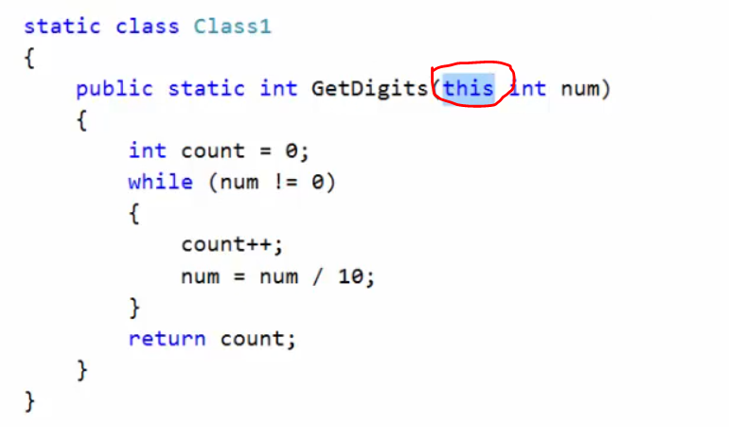

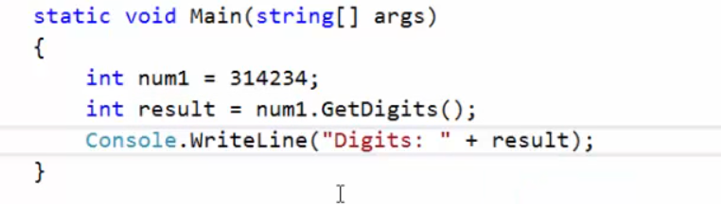

**Attributes**

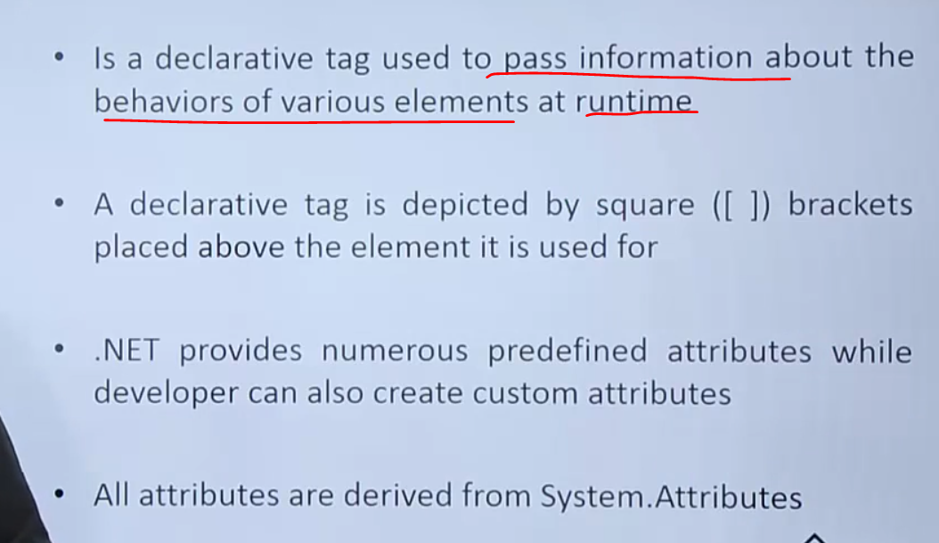

Why use the **parameterized** constructor?

Assign different values to the class members,

Why use the default constructor?

Assign default value to the class member;

Difference between **array** and List

List grow in size **automatically**,

But array do not grow in size **automatically**.

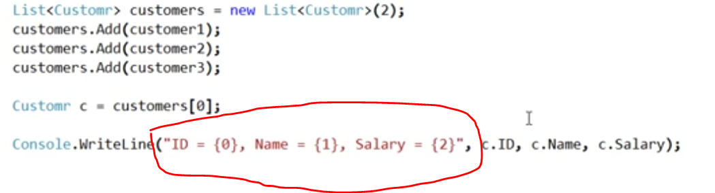

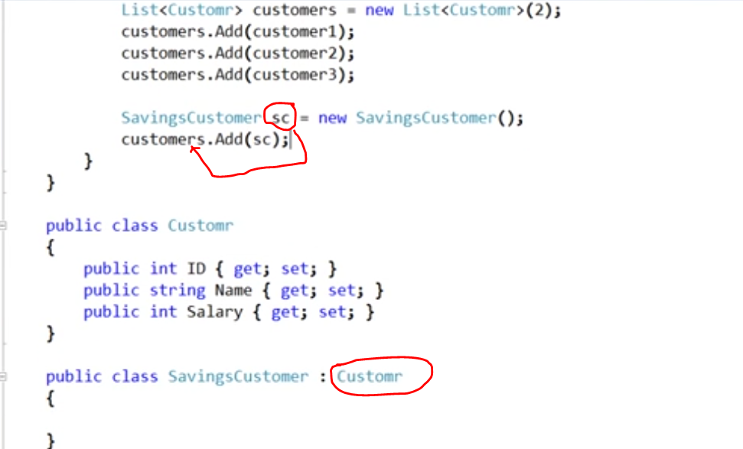

SavingCustomer Class in **inherit** from the Customer ,therefore ,we can add SavingCustomer object to the Customer list .

Generic collection classes in

* Dictionary
* List
* Stack
* Queue

List can be used to create a **collection** of any **type**.

**Delegates**

Delegate is a type safe function pointer.

If we add **delegate** key word to the method it become the delegate.



To make delegate to point to a function, we have to create instance of delegate.

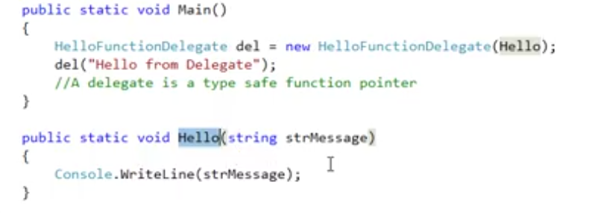

Type safe



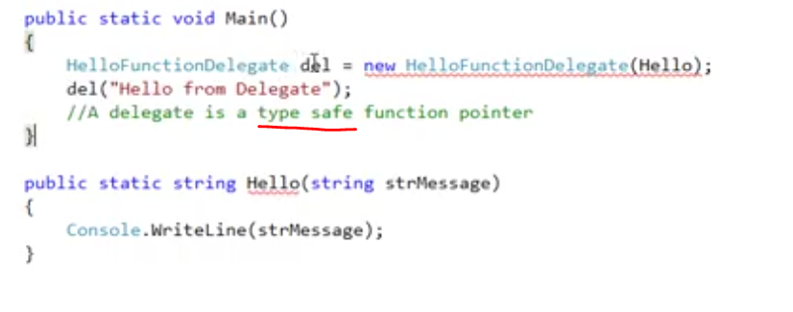

Note-Signature of delegate must match the signature of the method.

**Func Delegates**

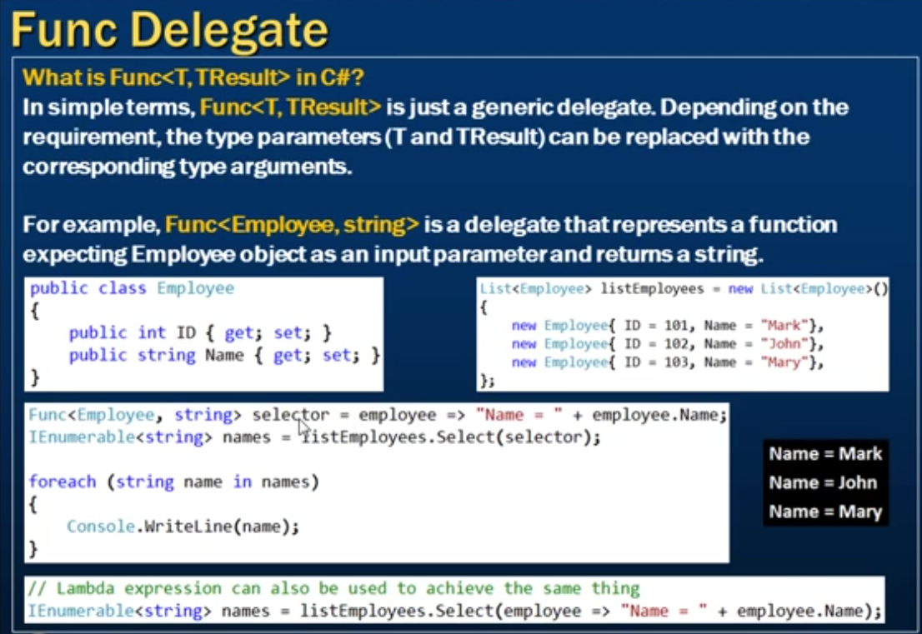

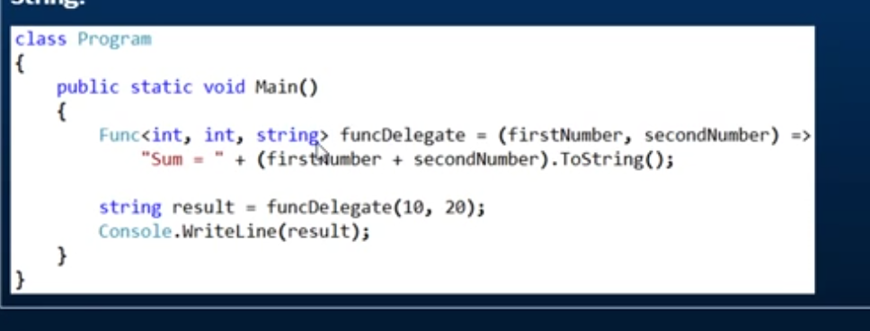

Anonymous method

Method that is no name.we can achieve Anonymous method by using **delegates**

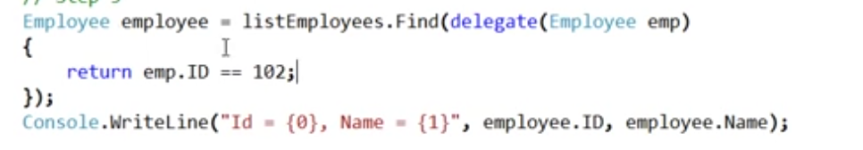

Anonymous method ,delegate parameters are optional.

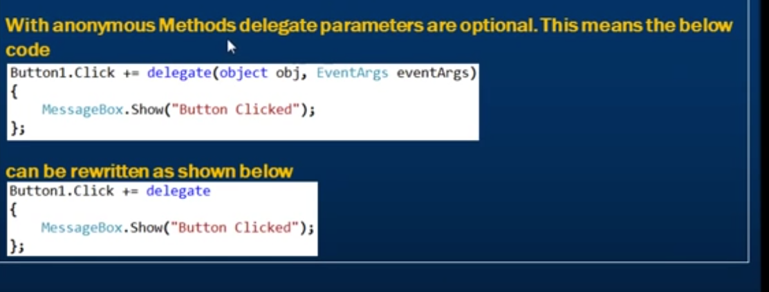

Why should you override the **ToString** method?

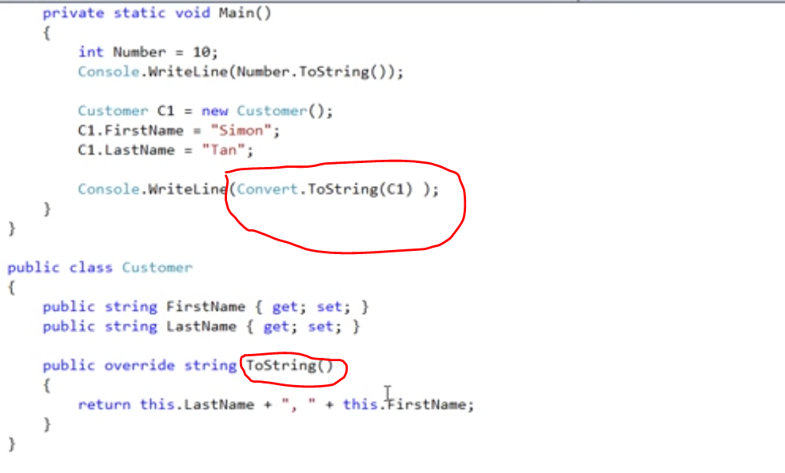

**Indexers**

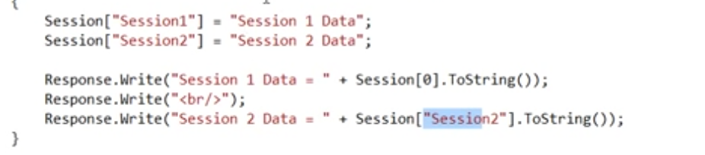

This is the place that we use the **indexers** in c#

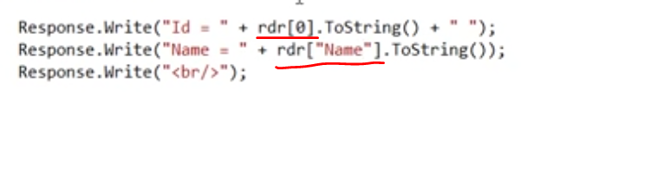

Two **Indexes**

* Integral indexers
* String indexes

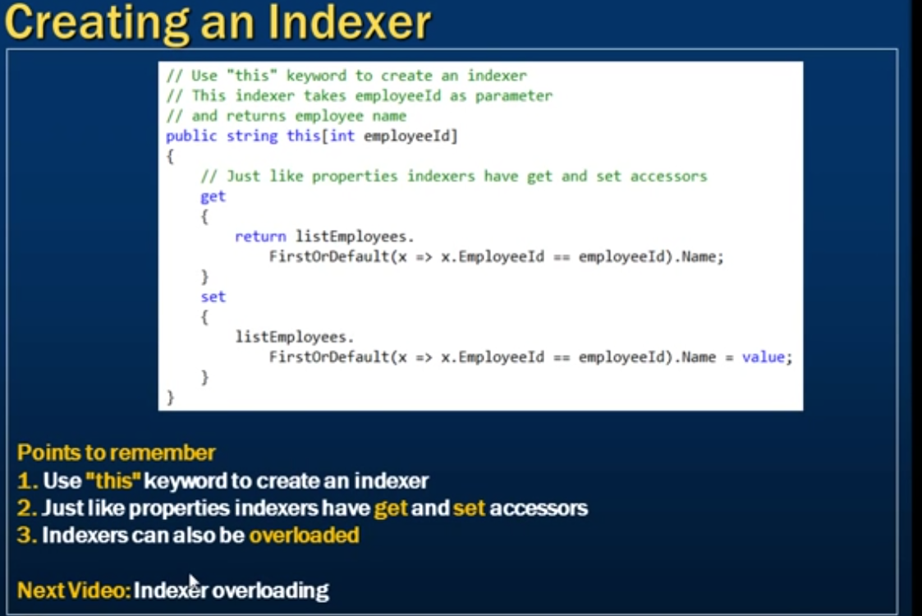

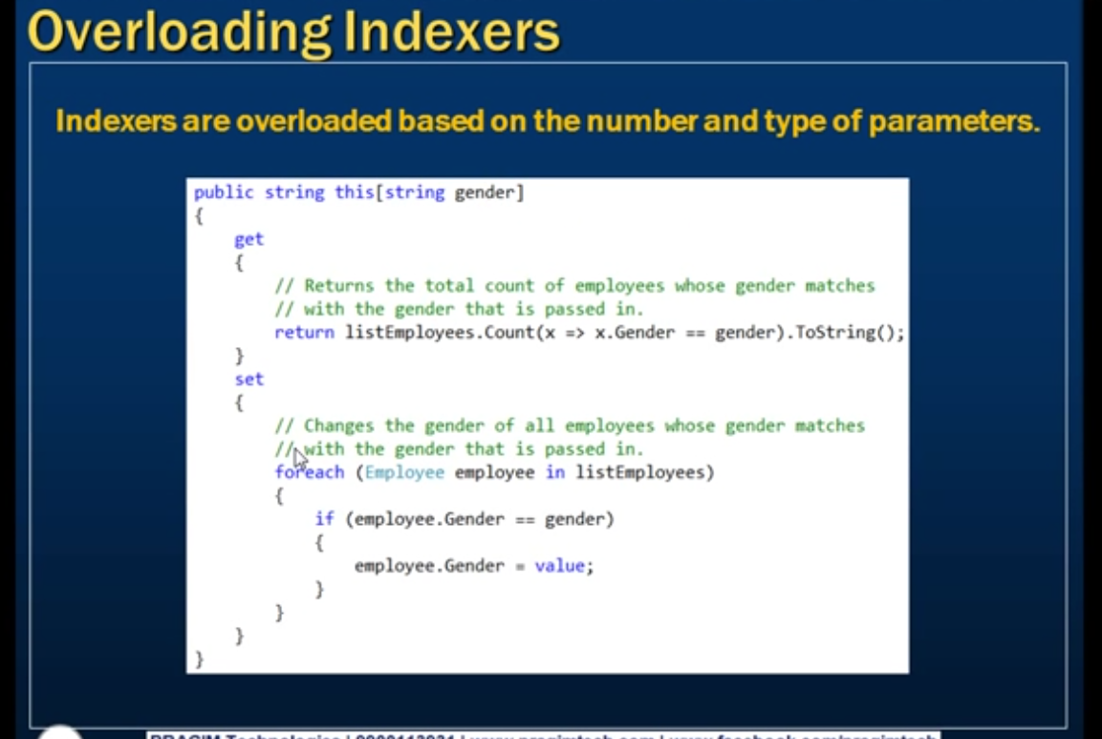

**Creating indexers**

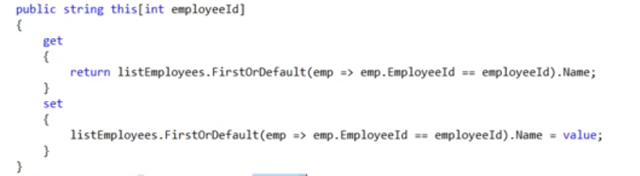

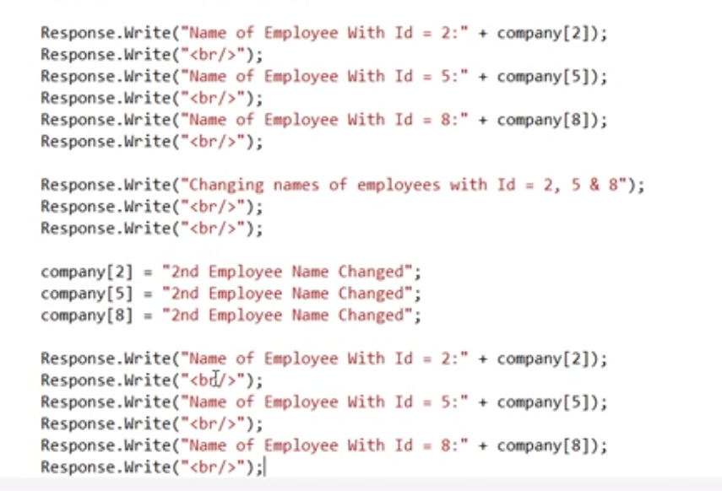

**Stack and Heap**

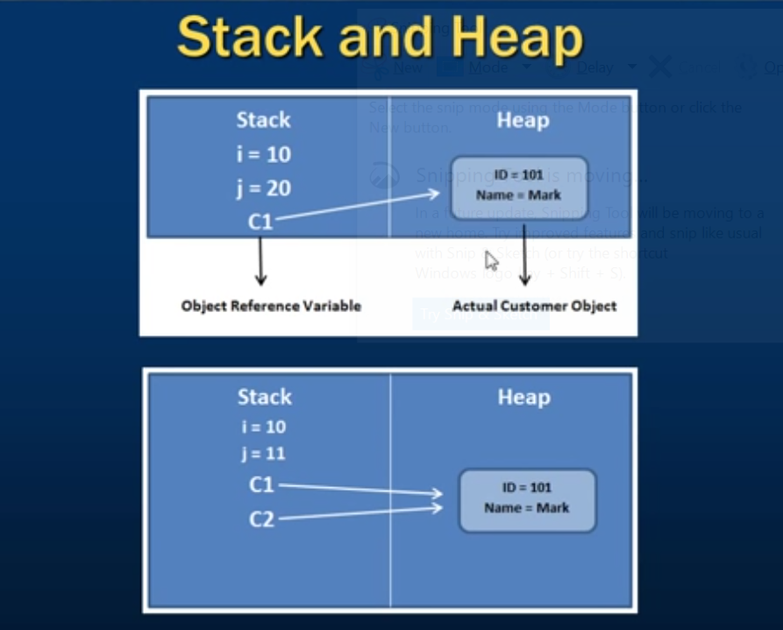

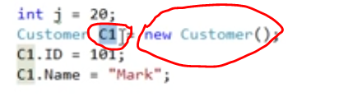

**Value** type destroy immediately after scope lost,

In **reference** type only the object reference destroy , object keep in memory until garbage collected and garbage collector will remove it.

If copy two object,two reference variable create in stack ,but this two reference variable pointing to the same object.

**Struct**

Struct don’t have the destructors,but class have the destructors.

Struct don’t have **paramterless** construtor,

Struct can’t inherit from **another class**.But struct can inherit from interface.

Class or struct cannot inherit from struct because struct is **sealed**.

**Properties**

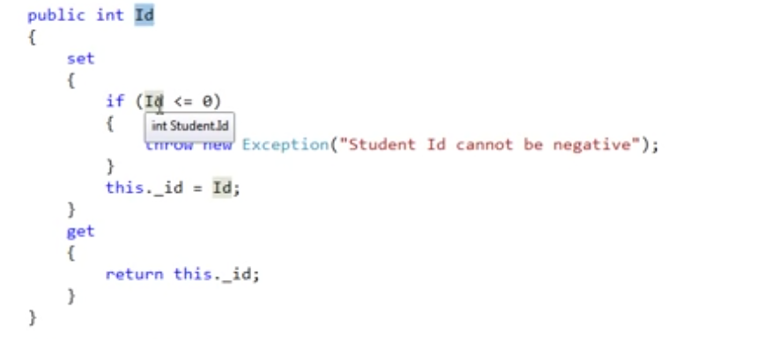

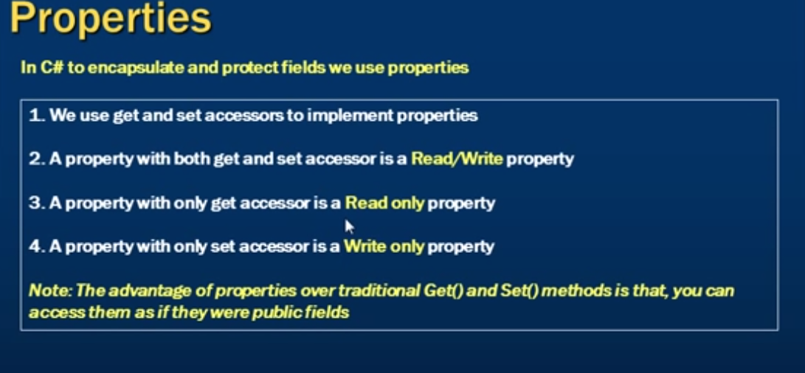

**Geter** and **setter** of property used to **encapsulate** and **protect data**.

Property avoid the **exposion** of private filed from **outside world**

Make filed as public bad and expose to the outside world is bad

#### Why And When To Use Enums?

An **enum**is a special "class" that represents a group of ****constants****

Use **enums** when you have values that you know aren't going to **change**, like month **days**, days, colors, deck of cards, etc.

enum Months{

January, // 0

February, // 1

March=6, // 6

April, // 7

May, // 8

June, // 9

July // 10}

static void Main(string[] args){

int myNum = (int) Months.April;

Console.WriteLine(myNum);}

**IsPostBack**

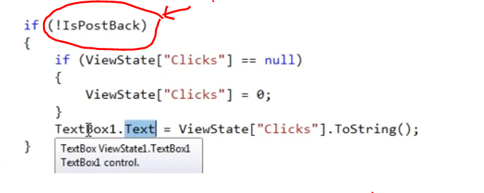

!IsPostBack-this is not a post request it is a get request

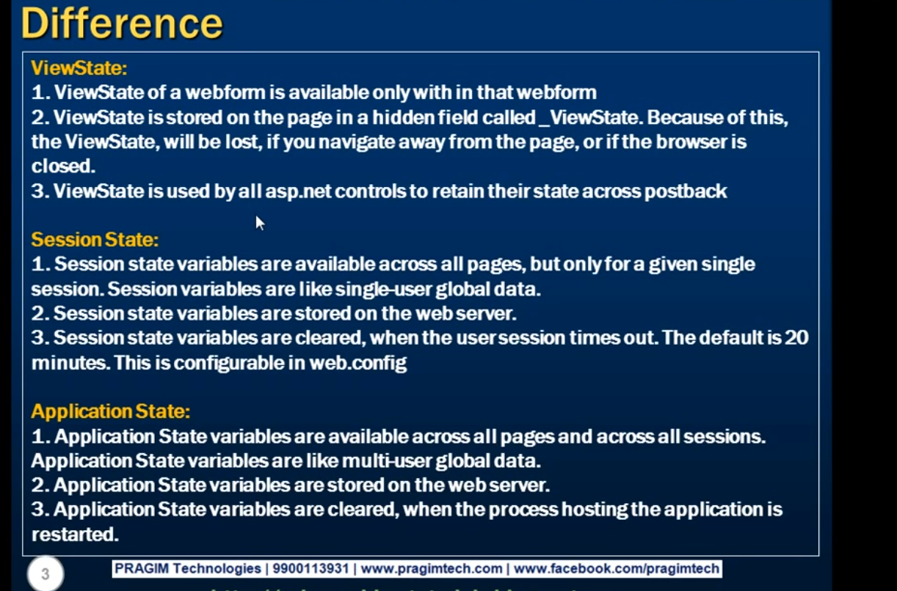

**Handle Error Globally**

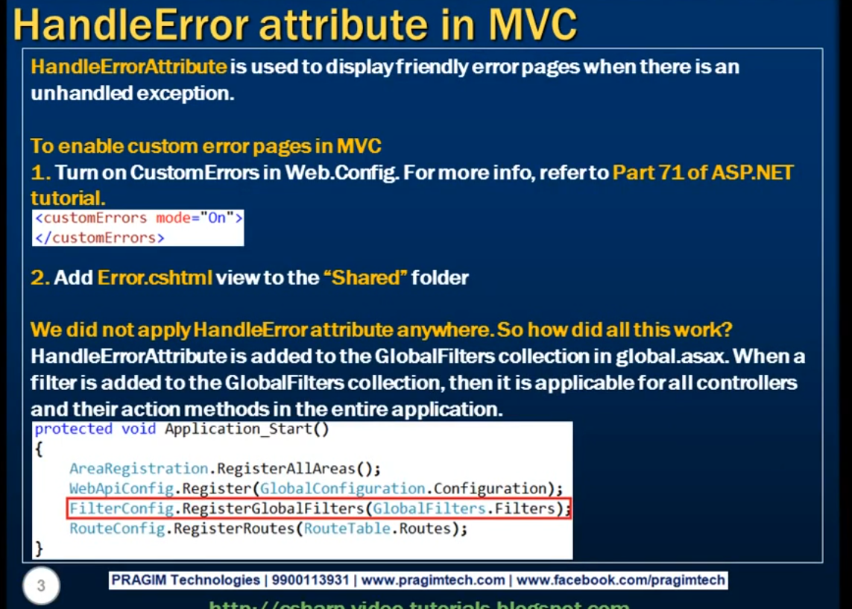

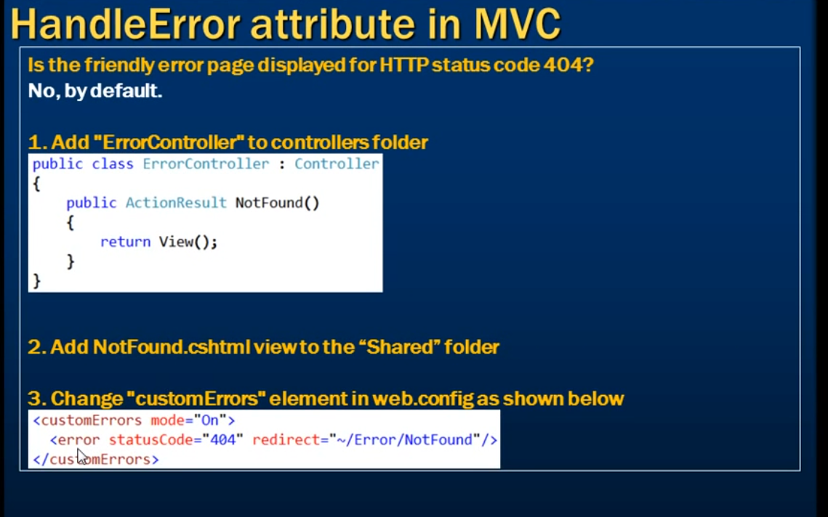

##### ****What are the different types of Routing supported by ASP.NET MVC?****

In ASP.NET MVC application, we can define routes in two ways. They are as follows:

1. ****Convention Based Routing****
2. ****Attribute-Based Routing.****

##### ****Different ways to implement Authentication in MVC:****

There are many different ways to implement Authentication in MVC. Here in this article series, we are going to use the following two ways to implement Authentication and Authorization in MVC application.

1. ****FormsAuthentication****
2. ****ASP.NET Identity****

Using **event** object in Javascript

Event object include -

X nad y cordinators,

Tagname

Type-click,mouseover,focusout

Event.target.type= button/text

Event.target.tagname=Input/Buton